Project Report Template

1 Introduction

The Job Application tracking system is software for recruiters and employers to track candidates throughout the recruiting and hiring process. It organizes information about job seekers and makes it searchable.

* 1. Overview

Job Application Tracking system tracks candidates through the hiring process. It helps with interview scheduling, issues notifications and alerts and sends automated emails to candidates and employees such as recruiters and hiring managers. It may conduct a preliminary analysis of the applicants to find the best fits for a job.

It helps to organize manage each step of the hiring process, from writing the job add to making a job offer. This include integrating with major job boards to streamline job postings, organize applications and allow candidates to create profiles. It keeps track of all the activity that takes place around the candidate.

* 1. Purpose

It saves lot of time compared to conventional application processing and hiring procedures.

It is the flexible system for Both Employer and the Agency.

Job Application Tracking system lets you upload your job openings on several platforms with a single click.

It helps is making better and faster decisions.

Collaborative hiring allows a company to have an organized approach to developing a diverse and talented team.

Whether hired or not, a candidate is bound to have an impressive experience with an a

Automated Application Tracking System.

2 Problem Definition and Design Thinking

2.1 Empathy Map

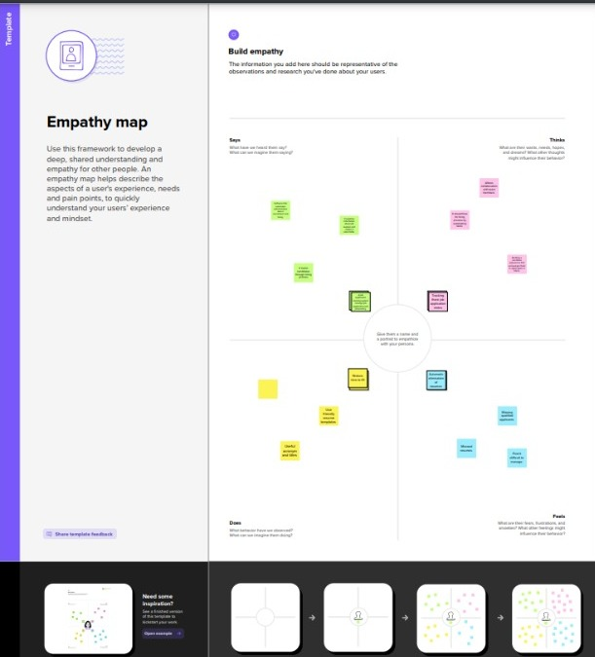

2.2 Ideation and Brainstorming Map

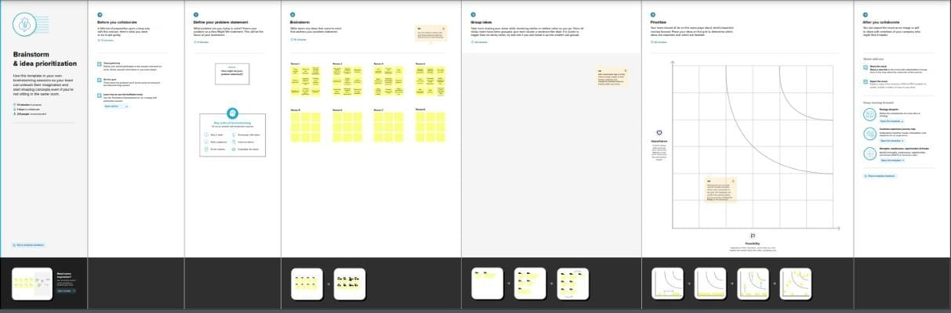

3. RESULT

3.1 Data Model

|  |  |
| --- | --- |
| Object name | Fields in the Object |
| Recruiter | |  |  | | --- | --- | | Field label | Data type | | Job title | Text | |
| Jobs | |  |  | | --- | --- | | Field label | Data type | | Recruiter | Master Detail Relationship | | Description | Text Area | | Location | Text | |

* 1. Activity and Screenshot
* Sign in to the Salesforce by entering the required data.
* After login the setup page will appear from that Click on Object Manager.
* Create custom object such as recruiter, jobs, candidate, job application object and tab by selecting new custom object.

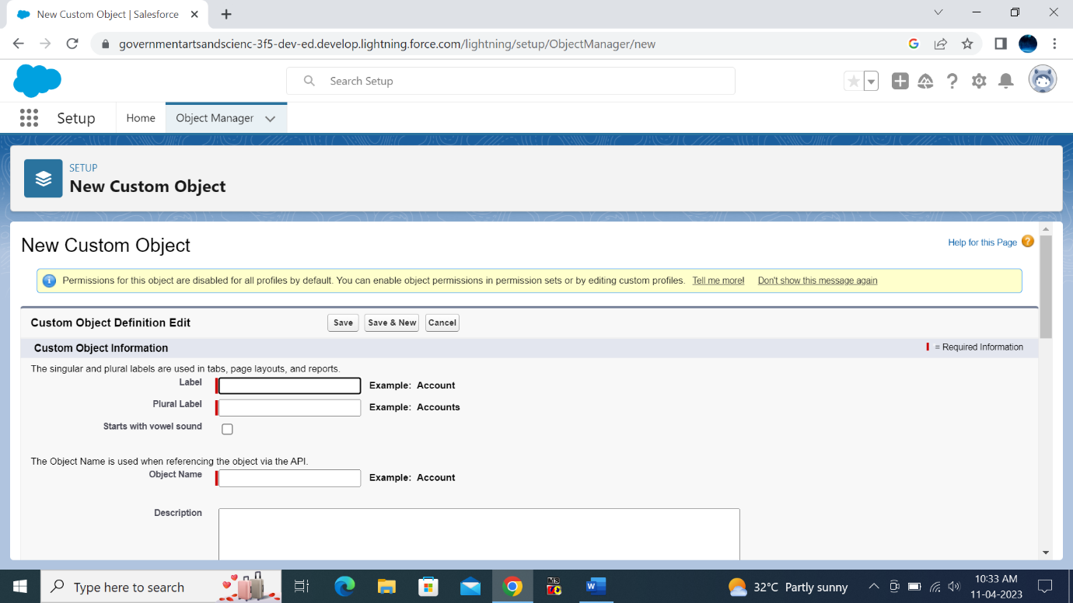

Fields:

Create the custom fields

* Click on fields and relationship then click new and create the given field by giving required data and then click save.

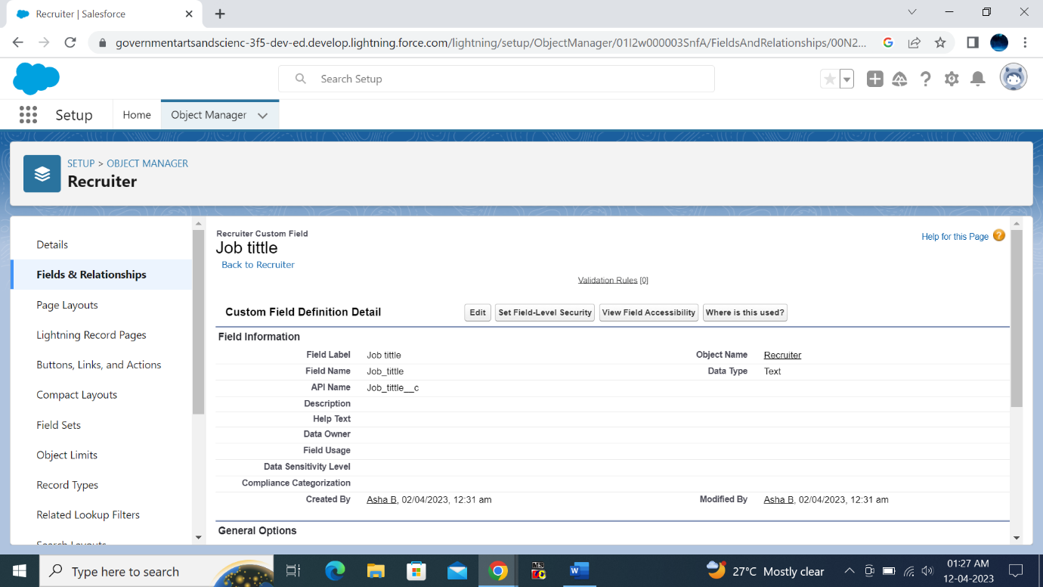

Creation of Master detail relationship

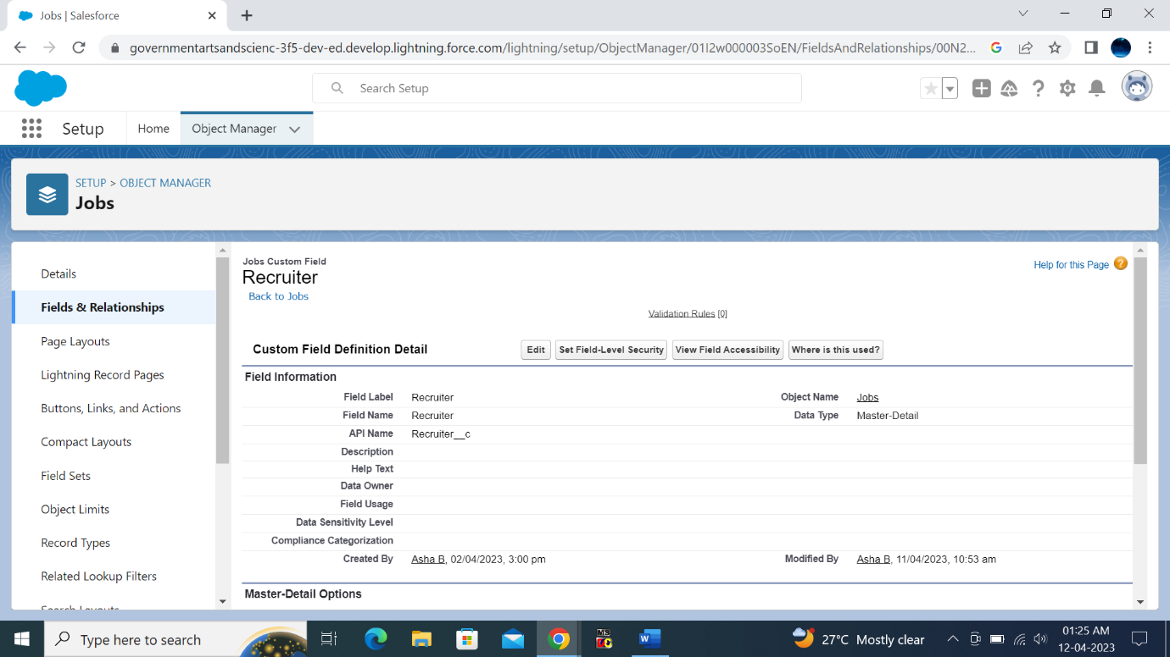

Create a new custom field

Create a new custom field with field label as description and chose the data type as text.

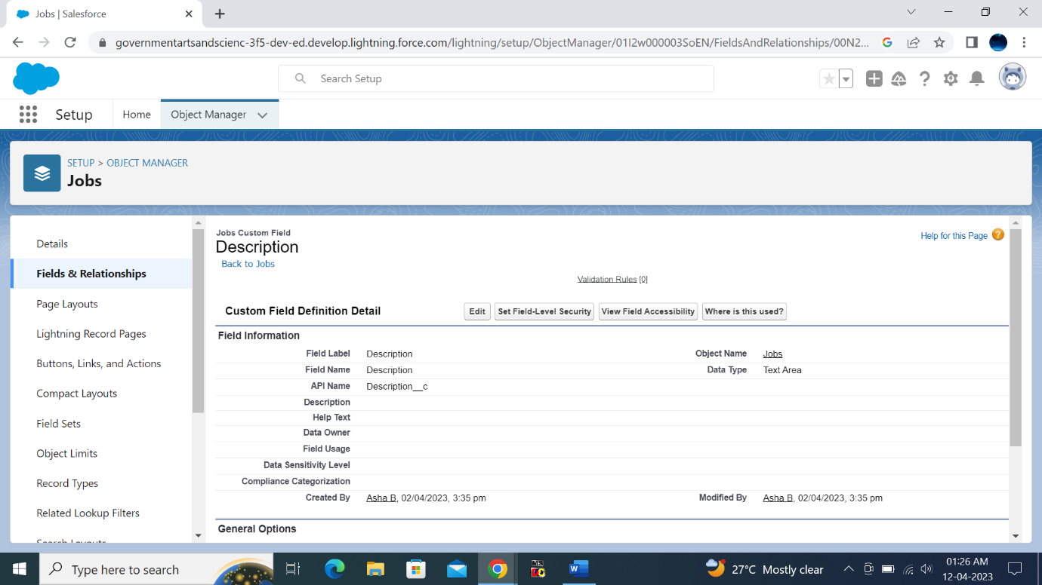

In the same way create a new custom field and give the label name as location.

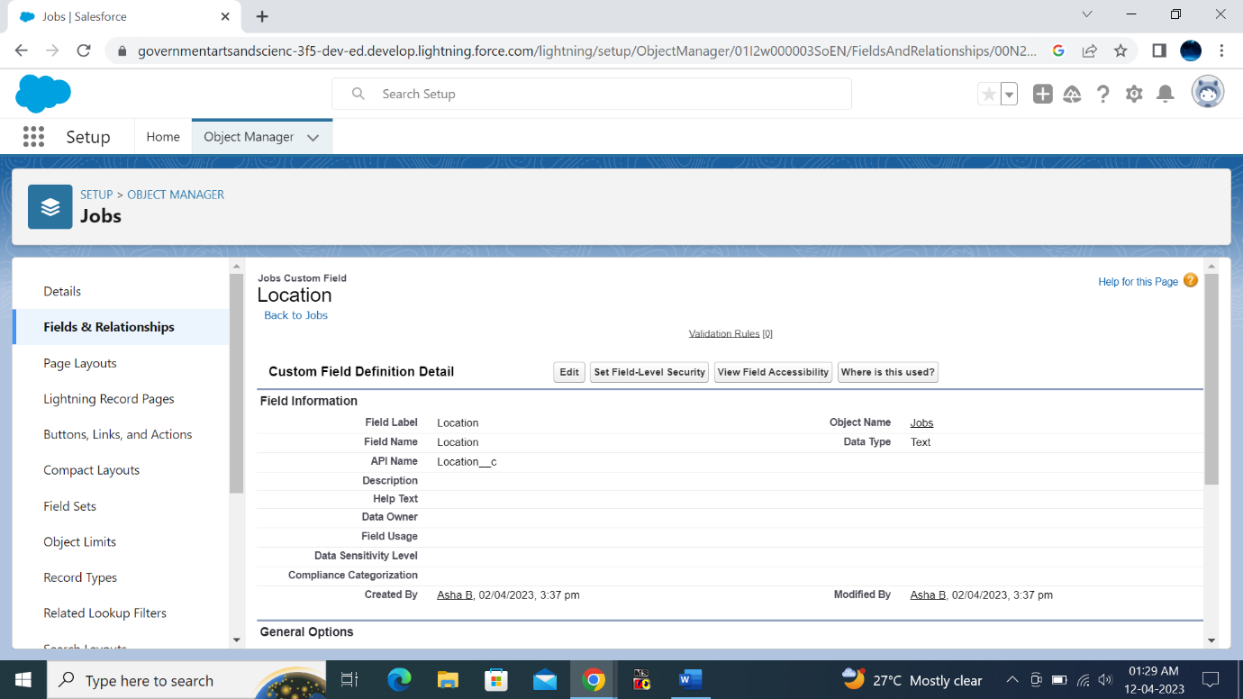

Tab

Create a tab

In the quick box search tab, click on new custom object then select the tab style and then click on save.

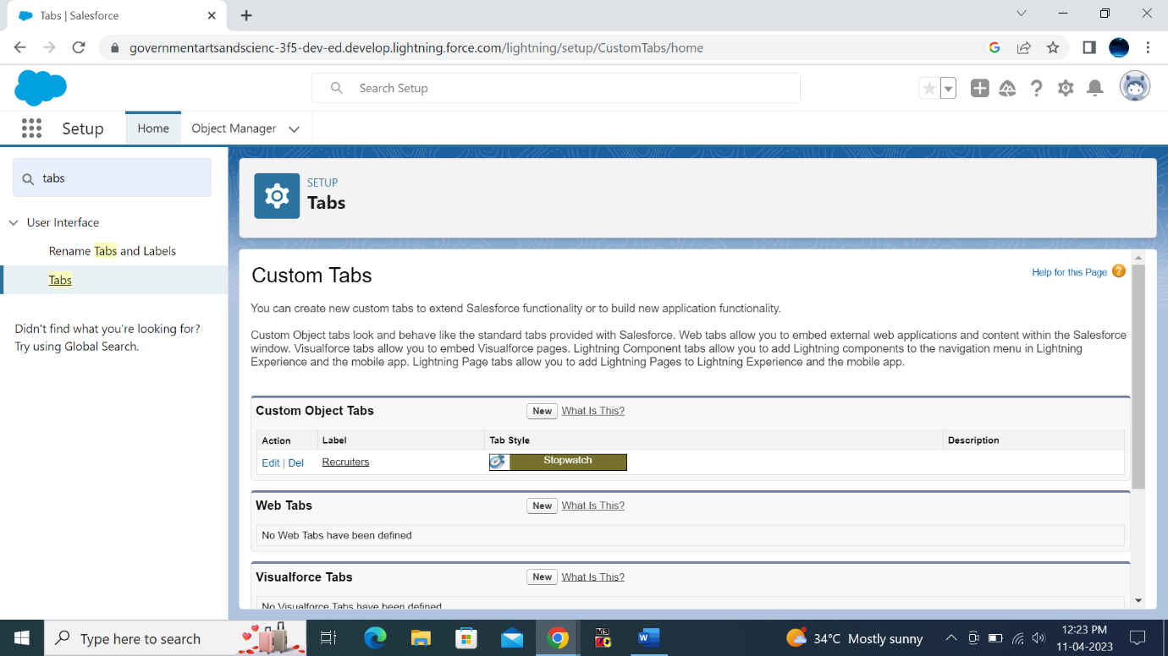

Profile

From the setup enter profile in quick find box then select standard user and click clone enter the label name as recruiter and then click save.

In the same way select the label name as sales Manager by following the same steps.

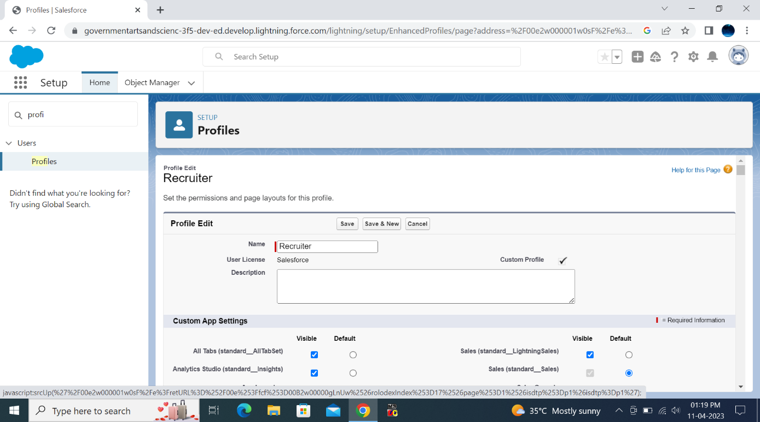

Profile of sales manager

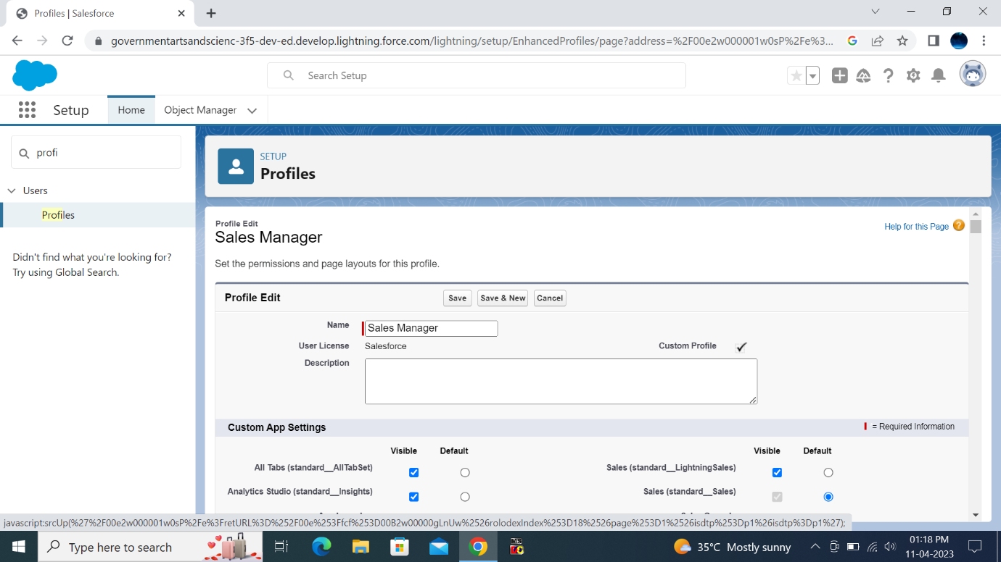

User

From setup enter users in the quick find box then click on new user then enter the name as Hr Manager and the role as Hr Manager the select the user License as Standard Platform User and then click save.

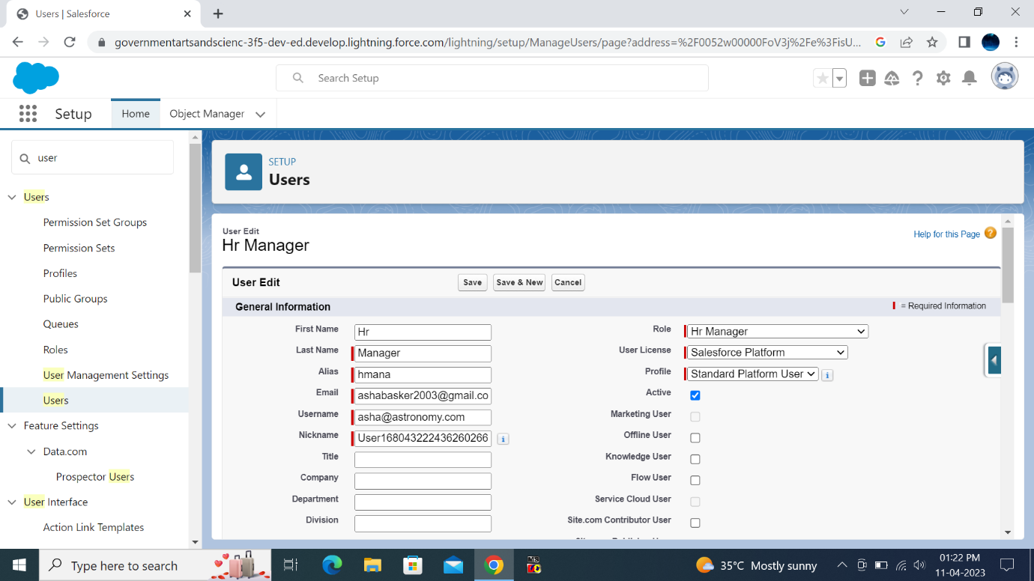

In the same way create new user name as Ganesh Gelli and assign him the sales manager profile and then click save.

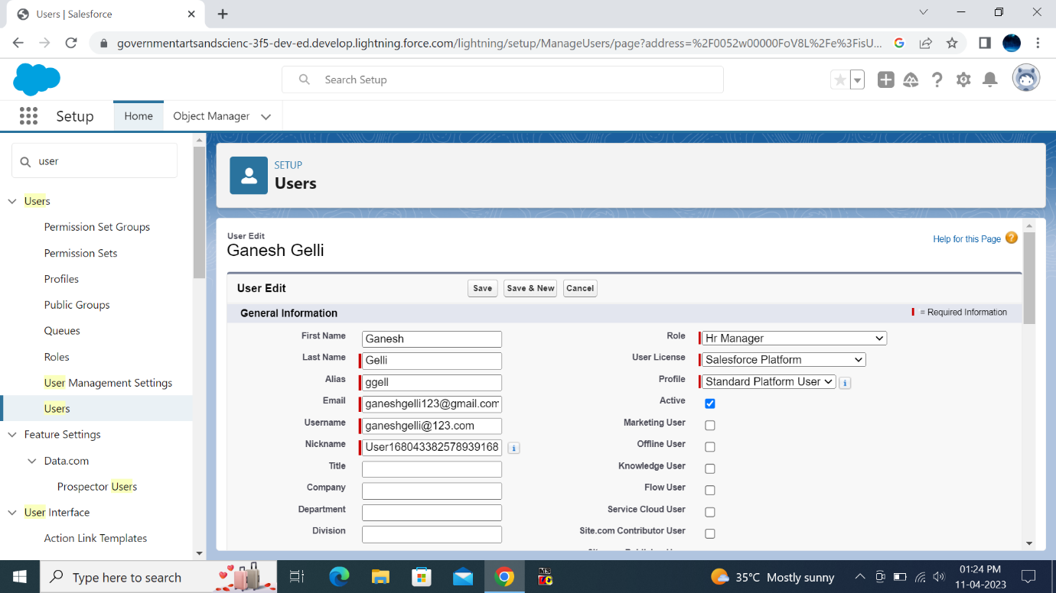

Sharing Rules

In the quick find box select sharing settings, find candidate object and then click on to create new sharing rules enter the given data and then select roles and in that select Hr Manager. Then give access to Read/write.

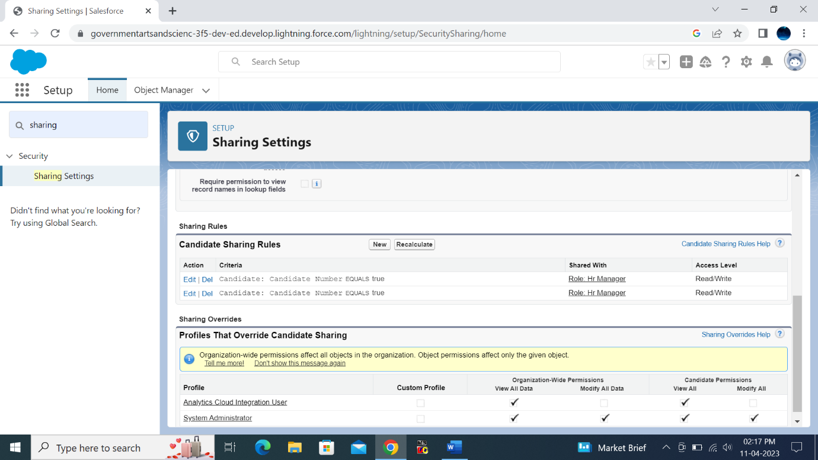

In the same way create the sharing rule to share the records of Job Application to Hr Manager with the access of read/write.

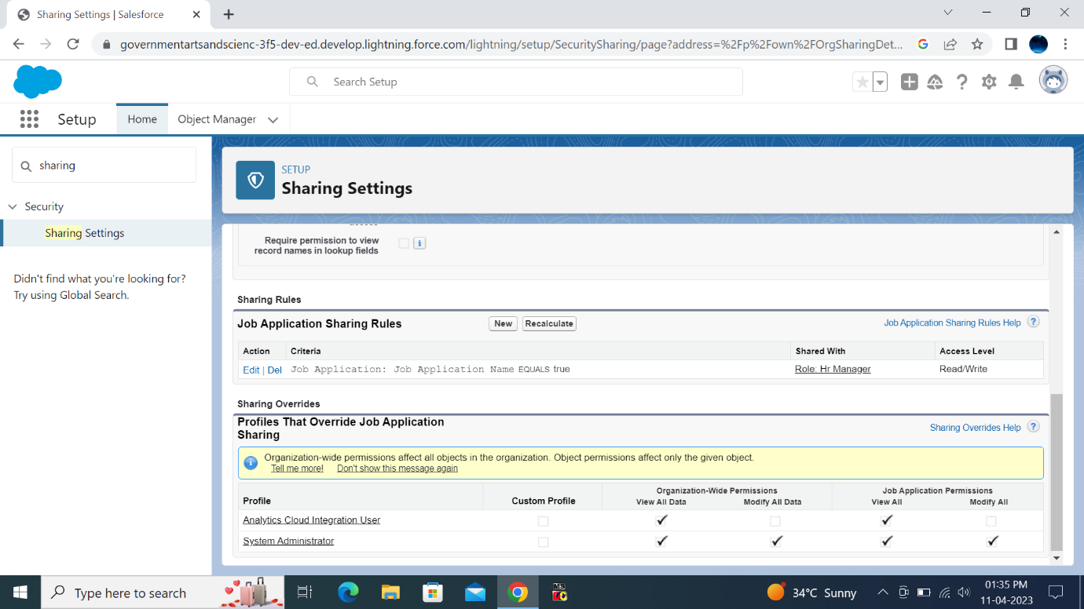

Reports

Click on the app launcher and then search for reports. Create new report by selecting accounts and contacts. And select the group columns and rows as given then save the report by giving the label name and select public folder.

In the same way create reports for Objects Jobs, Candidates and Job Application.

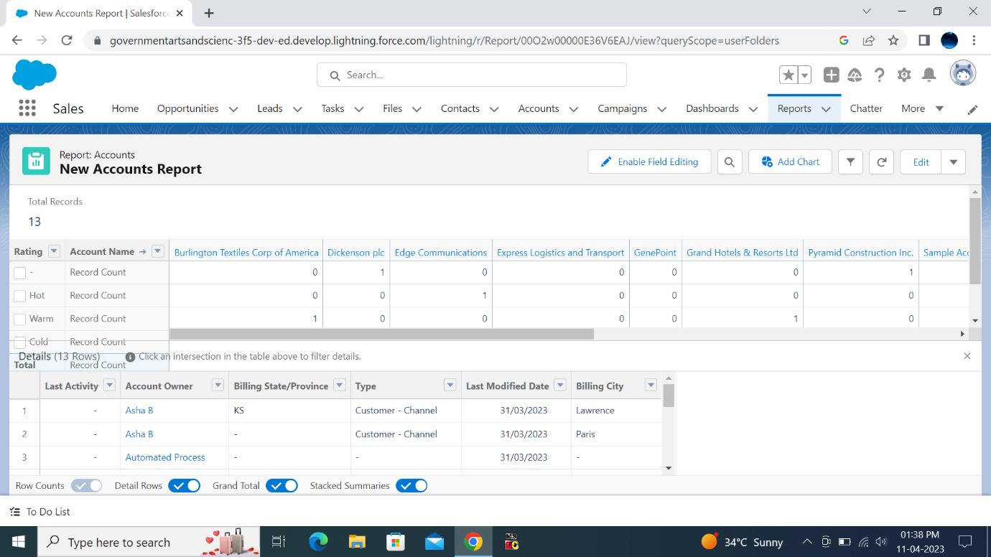

Reports of Accounts, Jobs, Candidate and Job Application.

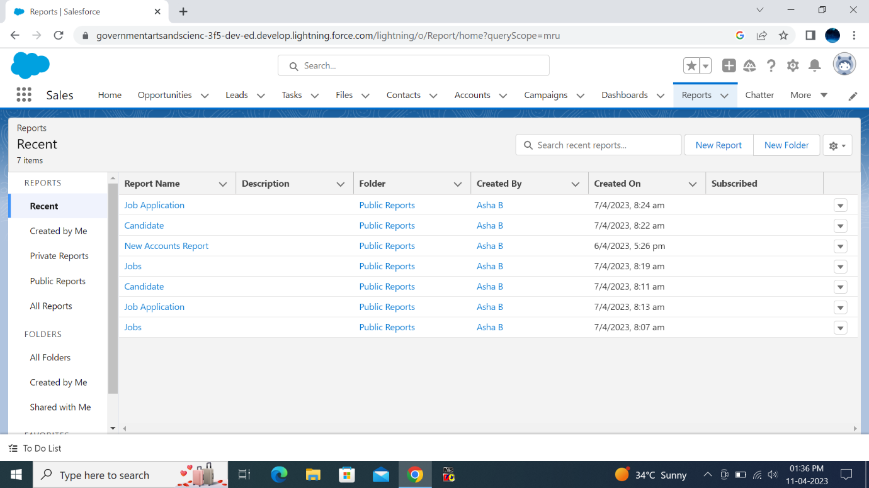

1. Trailhead Profile Public URL

Team Lead-https://trailblazer.me/id/asha323

Team Member 1-https://trailblazer.me/id/labishar

Team Member 2-https://trailblazer.me/id/ii05p

Team Member 3-https://trailblazer.me/id/iasmihav

1. ADVANTAGES AND DISADVANTAGES

Advantages

* Improves the quality of hire.
* Posts jobs on multiple job boards.
* Saves time by automating task by itself.
* Easy to track your job application
* Manages talent database.

Disadvantages

* Missing qualified applicants due to wrong keyword selection.
* Automatic elimination of every resume that the system cannot able to read.
* Misread resumes in the pdf format.
* Incorrectly categorized data from resumes due to the creation of resumes in unusual format.

1. APPLICATIONS

* Companies
* Educational institutes
* Organisations

1. CONCLUSION

We learned many things about salesforce and to create objects, sharing rules and creating reports etc.

1. FUTURE SCOPE

The next generation of job application tracking system that update your existing resume data to enable intelligent screening and searching.